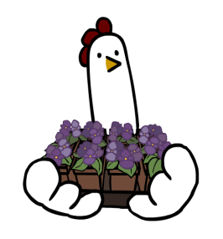
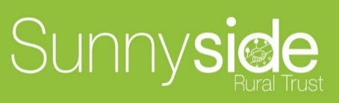
GARDENER RECRUITMENT
Based at Northchurch, Berkhamsted and Hemel Hempstead
Sunnyside Rural Trust is a registered charity and has built an innovative model of care-based support around offering training and work experience to adults with Learning Disabilities, within a social enterprise and horticultural setting. Across our services we grow a range of fruit, vegetables, herbs, plants including a large number of bedding plants for Dacorum Borough Council, and perennial plants for a variety of local buyers, coppice wood, conservation projects and we have 2 farm shops. We also look after pigs, sheep goats and chickens.

We are looking for an experienced gardener to join us. You will be offering support to groups of young people and/or adults with learning disabilities to develop their work skills. We are looking for people who are passionate about improving the lives of people with Learning Disabilities and creating opportunities for them to develop.

The ideal candidate will need to be enthusiastic and motivated. You will be working within a supportive team to help grow our outside gardening contract services. Excellent communication, an open & inclusive working style and team working skills are essential. You will need a pragmatic and creative attitude with the skills to empower people. Experience with working with people with Learning Disabilities as well as horticultural skills are essential, along with the ability to work outdoors. You will need to be willing and able to drive our minibuses and work vehicles, and use horticultural machinery.

Salary is £22,425 we also offer a range of attractive staff benefits and great development opportunities. We will consider full and part-time hours.

Closing date: 26th April 2024

For an application pack please contact Lynn@sunnysideruraltrust.org.uk
or visit our website www.sunnysideruraltrust.org.uk

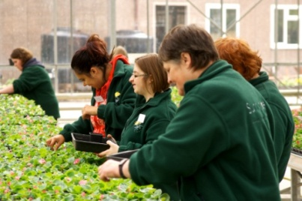
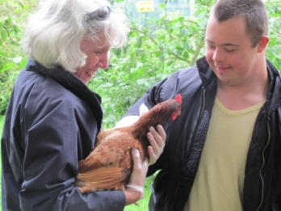
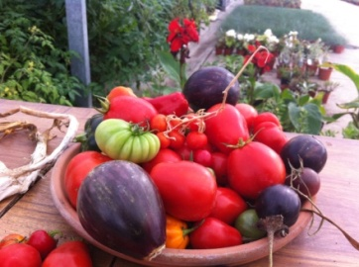

,

To learn more about what we do visit.
www.sunnysideruraltrust.org.uk

Sunnyside Rural Trust is an equal opportunities employer.
We welcome and support applicants with disabilities.

