JOB APPLICATION FORM

Please return applications to:  Lynn Adams, Service Manager  Sunnyside Rural Trust  c/o Civic Centre  161-163 High Street  Berkhamsted  Hertfordshire  HP4 3HD  Or email to  Lynn@sunnysideruraltrust.org.uk  *Please use correct postage to return forms* | 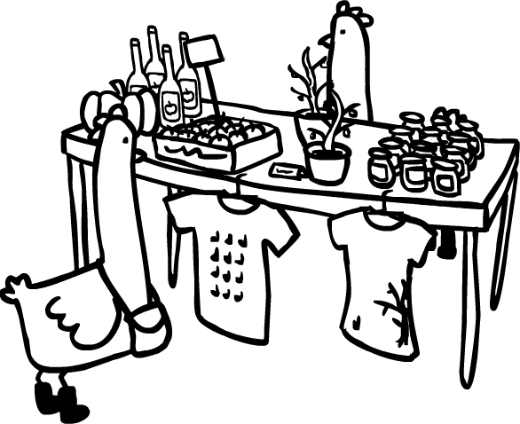  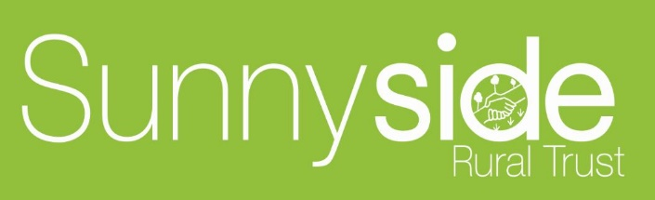

Position applied for:

Please print clearly and complete all sections.

1. PERSONAL DETAILS
Title:

Full Name:

Address:

Post code:

Contact details: Home telephone:
Mobile telephone:
E-mail address:
My National Insurance No. is:
In accordance with section 8 of the Asylum and Immigration Act 1996 we are required to ensure that only those legally entitled to work in the UK are employed by us.

Do you require a work permit or visa to work legally in the U.K.? YES / NO

If you are offered a job you will be required to provide proof of your identity.

2. EDUCATION AND QUALIFICATIONS

3. TRAINING
Courses attended | Training provider (this may be an employer) | Date/s attended

4. CURRENT OR MOST RECENT EMPLOYMENT
Employers business name:

What type of business is this?

Employers business address:

Post code: Telephone number:
What is/was your job title?

When did this employment begin?

What are/were your main duties and responsibilities?

What is/was your salary?

What other benefits do/did you get?

Why do/did you want to leave your current job?

What notice do you have to give if currently employed?

5. PREVIOUS EMPLOYMENT Give details of all other employment in the last 5 years
Dates |  | Name of employer | Employers postal address | Your job title | Salary
From | To

6. SKILLS

What skills and qualities do you think you can bring to this position?

Please read the person specification and job description carefully to ensure you meet the criteria for the role you are applying for. You can continue on a separate page if necessary

7.FLEXIBILITY

Some of our jobs involve flexible working and may be full time of part time.

Do you prefer to work: Full Time

Part Time (please state hours)

Are there any times/days that you are unable to work:

Are you intending to work for any other employer while working for Sunnyside Rural Trust? YES / NO

Are you able to work at different locations where Sunnyside carries out its business? YES / NO

Would you be prepared to use your own car for business purposes?

YES / NO

Do you have a clean driving licence?

YES / NO

Are you prepared to drive a Trust minibus?

YES / NO

8. ALL ABOUT YOU
Please give details of any activities or roles which you feel are relevant to your application.

Do you know anyone that works for or on behalf of Sunnyside Rural Trust, in any capacity? YES / NO
If yes, please give their full name(s):

9. DISABILITIES

Sunnyside Rural Trust gives full and fair consideration to applications received from people with disabilities who possess the appropriate skills or qualifications for the job to be filled.

If assistance is required with the application or participation in any interview or selection event please contact a member of the administration team at our Berkhamsted office.

10. DATA PROTECTION

The information you provide in this form and during our recruitment process will be used by Sunnyside Rural Trust to evaluate your application for employment. It may also be used for statistical analysis.

In the event of your employment the information will also be retained and used for business purposes.

If your application is unsuccessful your data will be retained for a maximum of six months and will then be destroyed.

11. REFERENCES
Please provide the names and contact details of two persons who we can contact for a reference. One should be a previous employer. (Note: we will not approach referees without your permission)
1 | Name: Mr, Mrs , Ms.  Profession/job title:  Relationship to you:  How long known to you? | Address:  Postcode:  Daytime telephone numbers:  Email:
2 | Name: Mr, Mrs , Ms.  Profession/job title:  Relationship to you:  How long known to you? | Address:  Postcode:  Daytime telephone numbers:  Email:

12. DISCLOSURE PROCESS
All new employees will be required to obtain clearance from the Criminal Records Bureau/ DBS before they begin any employment with Sunnyside Rural Trust. This clearance process will disclose any and all convictions or cautions to us so that we may assess your suitability to work with vulnerable people.

13. CRIMINAL CONVICTIONS
To apply for a job at Sunnyside Rural Trust, you are required to disclose any unspent criminal convictions you have in line with the Rehabilitation of Offenders Act 1974. All posts also require the disclosure of all convictions, including those which are regarded as spent under provisions of the Rehabilitation of Offenders Act (Exceptions) 1975. You must therefore disclose all convictions you have ever had.

Any information given about convictions will be completely confidential and having a criminal conviction will not necessarily prevent you from working with us. Employment depends on the nature of the job and your offences.

PLEASE ANSWER THE FOLLOWING 3 QUESTIONS

I have spent criminal convictions to declare. Yes / No

I have unspent criminal convictions to declare. Yes / No

Have you ever been cautioned or subject to a bind over order? Yes / No

If you have ever had any criminal convictions please provide full details on a separate sheet of paper and place inside a separate sealed envelope with your application form.

Please mark this envelope for the attention of Lynn Adams – Private & confidential.

14. DECLARATION
Please read the following declaration and sign below:

I declare that the information provided in the whole of this application form is true, accurate and complete and I consent to all personal and sensitive data about me being stored and used for business purposes by Sunnyside Rural Trust.

I understand and accept that Sunnyside Rural Trust reserves the right to withdraw any offer of employment or summarily terminate any employment already commenced, without notice or payment in lieu of notice, if the information given by me on this form is untrue, inaccurate or incomplete.

I acknowledge that any offer of employment is subject to the receipt of satisfactory references, medical clearance, satisfactory disclosure from the Criminal Records Bureau, and I understand and accept that Sunnyside Rural Trust reserves the right to withdraw any offer of employment or summarily terminate any employment already commenced, without notice or payment in lieu of notice, if this information, when received, is deemed to be unsatisfactory to Sunnyside Rural Trust.

Signature: Date:

