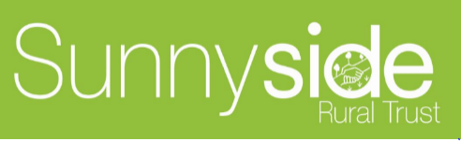 **Café**

**Menu**

**“Plot to Plate”**

**Prepared, where possible, with fresh seasonal ingredients from our allotment with vegan and gluten free options**

**(VE & GF)**

**Kids menu**

**MEAL DEAL**

**Comes with a packet of Pipers crisps & Sunnyside apple juice**

**Sandwiches for smaller appetites**

**Cheese, Tuna, Hummus, Peanut Butter or Sunnyside Jam**

**£3.45** one filling

**£3.95** two fillings

**Pizza**

**£3.95 Kids 7inch Margarita Pizza**

**£0.50p** optional extra for mini salad

Our food is prepared to order. We source our products carefully & locally where possible. We also use fair trade, British & organic products & all Sunnyside ingredients are grown to organic standards for meals where animal products are used we make sure the farms have high welfare standards. Despite doing our very best to reduce the risk of cross contamination, we do handle allergens so please tell us about any dietary needs or allergy.

**LIFT ME UP TO SEE WHATS GOING ON AT SUNNYSIDE**